|  |
| --- |
| Functional Design Document |
| CHG212979 |
| CHG OM: Transfer - Shopping Cart: UOM transfer further enhancement |
| Markets: All |
| Release: RLS000700 (Feb’22) |



Contents

A. Document approval 3

B. Revision history 3

1. Business Process Overview 4

1.1 Process Overview 4

1.2 Impact Matrix 4

2. Description of the functional change 5

2.1 Changes in Siebel Sales 5

2.2 English Captions 5

2.3 Changes in the ETL 5

2.3.1 Initial Loads/Massive Data updates 6

2.3.2 Performance test/Indexes creation 6

2.4 Changes in OBI 6

2.5 Data Dictionary 7

2.6 Changes in Data Interfaces 7

2.6.1 Inbound 7

2.6.2 Outbound 7

2.6.3. Initial Loads 8

2.6.4 Performance test / Indexes creation 8

2.7 Changes in Batch Processes / Aggregations / DRP 8

2.8 Use Case 8

# Document approval

|  |  |  |
| --- | --- | --- |
| Role | Name | Function |
| **Market Sponsor** |  |  |
| **DBU Approver** | Nikita Ryzhkovich | Digital Customer Experience |
| **BTS expert** | Elena Voronina | BTS TME Manager |
| **ODC expert** | David Gallego | ODC Sales |
| **ODC expert** | Fran / Migual Lopez | ODC Data |
| **GTC expert** | Jose Carlos Martin | TME Tech Arch Mgr |

This is to confirm that we have reviewed the functional specifications for the proposed solution. We agree with its contents and understand that the technical specifications will be designed based on this approved document.

# Revision history

|  |  |  |  |  |
| --- | --- | --- | --- | --- |
| Revision | Section(s) | Description | Editor | Date |
| 1.0 | - | Draft | J.Andreyeva | 10.02.2021 |
| 1.1 | 1.1 | Business Process updated | J.Andreyeva | 20.07.2021 |
| 1.2 |  | General Review | E.Voronina | 30.09.2021 |
| 2.0 |  |  |  |  |
| 2.1 |  |  |  |  |
|  |  |  |  |  |

# Business Process Overview

## Process Overview

During shopping cart creation (order creation process), trade marketers should be able not only select products, but also select the UOM in which the retailer would like to order (different from the product basic UOM which has been defined during product creation – refer to the CHG212558 where approach for product units of measure configuration and maintenance is being described).

Example: The product basic UOM for "Winston Blue" product is pack. In the shopping cart, the ordered quantity for the order UOM will be converted to the real quantity for the basic UOM. For example, the retailer is ordering 2 cartons, each carton has 10 packs, this converts to 20 packs in the order.

UOM and QTY (QTY field accepts decimals) should be carried through Shopping Cart and Order

QTY field would be convertible based on selected UOM conversion object (product defined at the Product level). Conversion value should be available on the mobile, values of the UOM would be driven from the conversion rate object.

For V2 further enhancement in the product master would be needed as it should be possible to associate product UOM to specific order type

Process wise, it’s expected that on mobile app, user would navigate to the order products subtab, add product to the shopping cart (manually or using product templates). In "Cart" subtab user see in column UOM the basic UOM for the product and if needed to apply different UOM, click the expand button under the UOM field, see different UOM available for the product for order and select the correct UOM Type (i.e. packs). After selecting the UOM the QTY button will work with the UOM conversion value.

## Impact Matrix

|  |  |
| --- | --- |
| GRM Functionality | Order |
| Impact Current Functionality | Yes |
| Markets Affected | All |
| Applications Affected | Sales / Data / BI |
| Risk of Implementing the change | Medium |

# Description of the functional change

## Changes in Siebel Sales

As described in the process overview section, as part of the order creation on the mobile application, it’s considered an ability for the trade marketer to choose product UOM which is different from the basic UOM defined on the product master (being described as part of the FD for CHG212558). Once mobile ap synchronizes to backend, the information should be available.

To support the described behaviour, the following changes are needed:

* Create additional fields on the ‘Order Entry - Line Items’ BC (Applet: JTI NUI Order Entry Line Item List Applet (Sales), Order Entry - Line Item List Applet (Sales), JTI Order Entry - Line Item List Applet (Sales) – Signature, JTI NUI Order Entry Line Item Summary List Applet, JTI NUI Order Entry Line Item Summary List Applet):
  + Basic UOM, text – new field introduced as part of the CHG212558 and being configured for product in Product Administration
  + Conversion, integer - new field introduced as part of the CHG212558 and being configured for product in Product Administration
  + Order UOM, text – new field that will allows to choose from different UOM associated to the product (as described in the CHG212558)
  + Order Quantity, integer – new quantity field populated on the mobile app (Quantity in UOM picked on Order creation)
  + Basic UOM Quantity, integer – new field should be recalculated using conversion value to the basic UOM, RO for the users

Note to @ODC: to verify if existing field Quantity can be re-used for the purpose described

The value of the ‘Basic UOM Quantity’ field should be copied to existing field ‘Quantity’.

The new fields should become RO once the order status is ‘Submitted’ or order ‘Export Status’ is equal to ‘Exported’

For example:

For ‘Product A’ Basic UOM is defined as Packs, additional UOM added is Outers, Conversion value is defined for the product from carton to packs (10 Packs = 1 Outer)

In the order line item, as Order UOM Outer was selected, Order Quantity was set to 10

Basic UOM Quantity would be calculated as 100 (Calculated Logic: Order Quantity * Conversion Value)

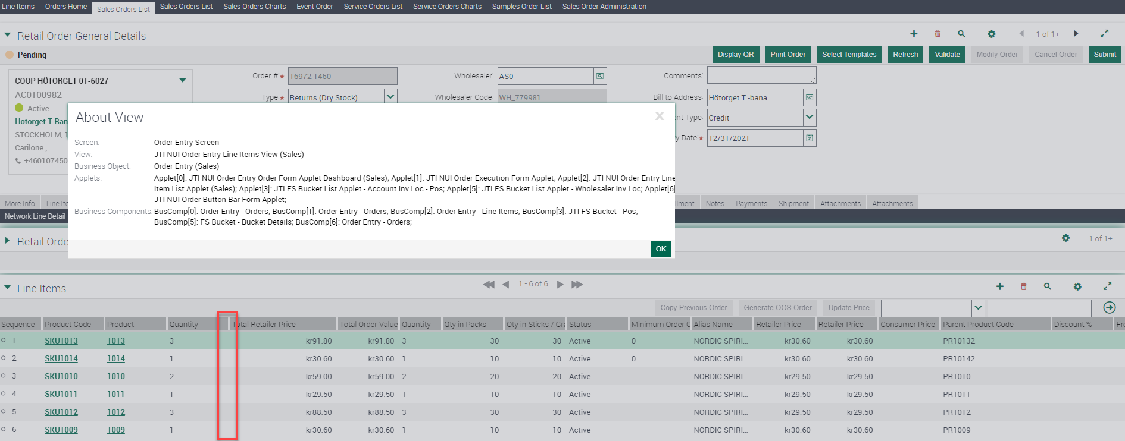

The fields should be hidden by default and added using ‘Columns Displayed’ feature.

Fields behaviour for the markets in Scope of V2 would be covered via additional change request

## English Captions

|  |  |  |  |  |
| --- | --- | --- | --- | --- |
| Type | Format | Caption ENU | Language | Caption LOCAL |
| Field |  | Basic UOM | ESN | UOM Por defecto |
| Field |  | Basic UOM | CSY | TBC |
| Field |  | Basic UOM | ITA | Unità di misura di default |
| Field |  | Conversion Value | ITA | Valore conversione |
| Field |  | Conversion Value | ESN | Factor Conversión |
| Field |  | Conversion Value | CSY | Převodní faktor |
| Field |  | Order Quantity | ESN | TBC |
| Field |  | Order Quantity | CSY | TBC |
| Field |  | Order Quantity | ITA | TBC |

## Changes in the ETL

|  |  |  |  |  |  |
| --- | --- | --- | --- | --- | --- |
|  | OLTP Source | | ETL | OLAP Target | |
| # | **Entity** | **Attribute** | **Transformation** | **Entity** | **Attribute** |
|  | Order Item | Order UOM |  | Order Item | Order UOM |
|  | Order Item | Order Quantity |  | Order Item | Order Quantity |

## Initial Loads/Massive Data updates

Not needed

|  |  |  |  |  |  |
| --- | --- | --- | --- | --- | --- |
| Data Update | | | | | |
| # | **Entity** | **Markets** | **Periods** | **Urgent (ODC)** | **Remarks** |
|  |  |  |  |  |  |

## Performance test/Indexes creation

Not needed

## Changes in OBI

Add Order UOM and Order Quantity to the order items dimension in BI

## Data Dictionary

Order UOM – UOM picked on order creation

Order Quantity – Quantity in UOM picked on Order creation

## Changes in Data Interfaces

## Inbound

|  |  |  |  |  |  |
| --- | --- | --- | --- | --- | --- |
| OI – order items, SI – orders inbound | | | | | |
| **#** | **Entity** | **Field Name** | **Contents** | **Data type/format** | **Transformation** |
|  | Order Item | Order UOM |  |  |  |
|  | Order Item | Order Quantity |  |  |  |

## Outbound

|  |  |  |  |  |  |
| --- | --- | --- | --- | --- | --- |
| SO – sales orders outbound | | | | | |
| # | **Entity** | **Field Name** | **Contents** | **Data type/format** | **Transformation** |
| 1 | Order Item | Order UOM |  | String |  |
| 2 | Order Item | Order Quantity |  | Num |  |

## Initial Loads

Not needed

## Performance test / Indexes creation

Not needed

## Changes in Batch Processes / Aggregations / DRP

Not needed

## Use Case

|  |  |  |
| --- | --- | --- |
| Role  Trade Marketer, ASM, Local Admin… | Application  Sales, Analytics, ETL, Batch, Interface | Step  Description of the step and its expected output |
| Trade Marketer |  |  |
|  |  |  |
|  |  |  |